**657092802**

Base URL:

**Agreement URL:** https://geomednews.com

* Use the Agreement URL as the main URL instead of using Source URL
* 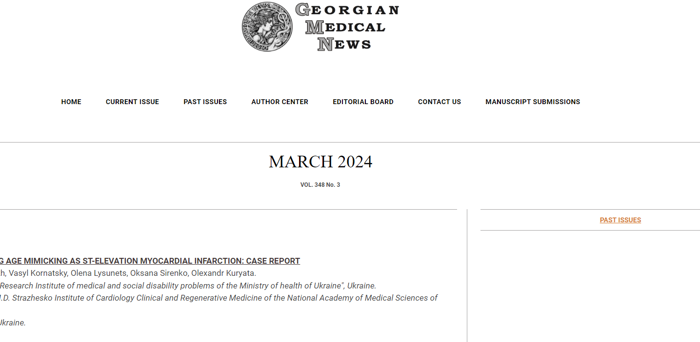Web page view as below
* Select number 1 to access **current issue**
* Select number 2 to access all the **current and past issues**



2

1

* After selecting past issues. Can access all the volumes and issues in every year
* 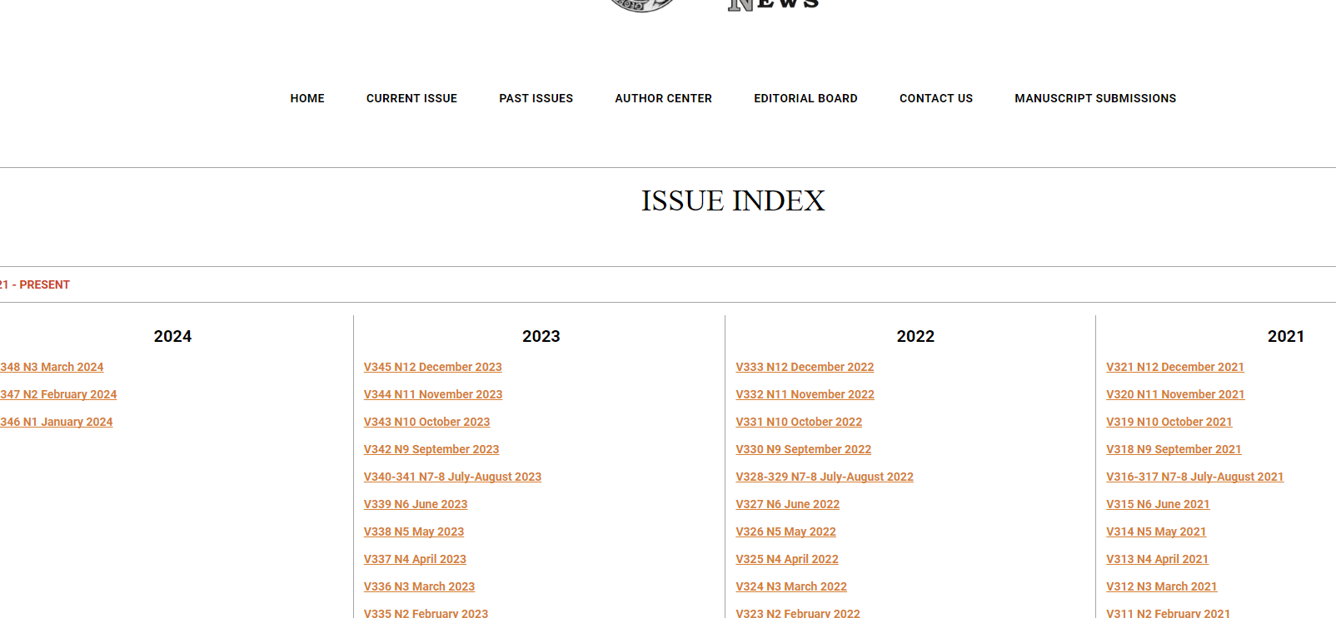All the volumes and issues are included in a single page
* Select the particular volume and issue that you need to process. From the list down below

List

# Metadata can be capture as below

# To download pdf and capture the URL. You must select the article

# DOI not available. Only the page range

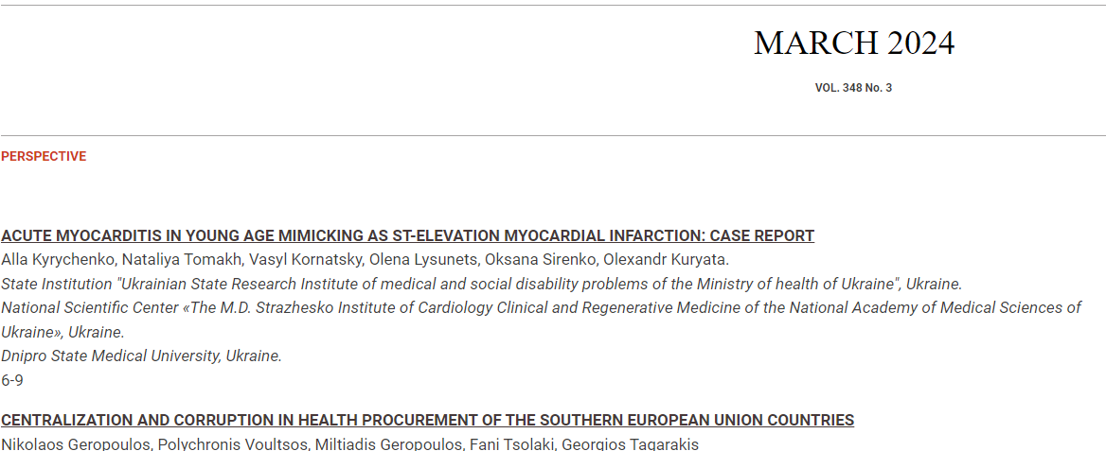

Article name

Volume, issue and year

Page range